St Albans Cricket Club

Established 1905

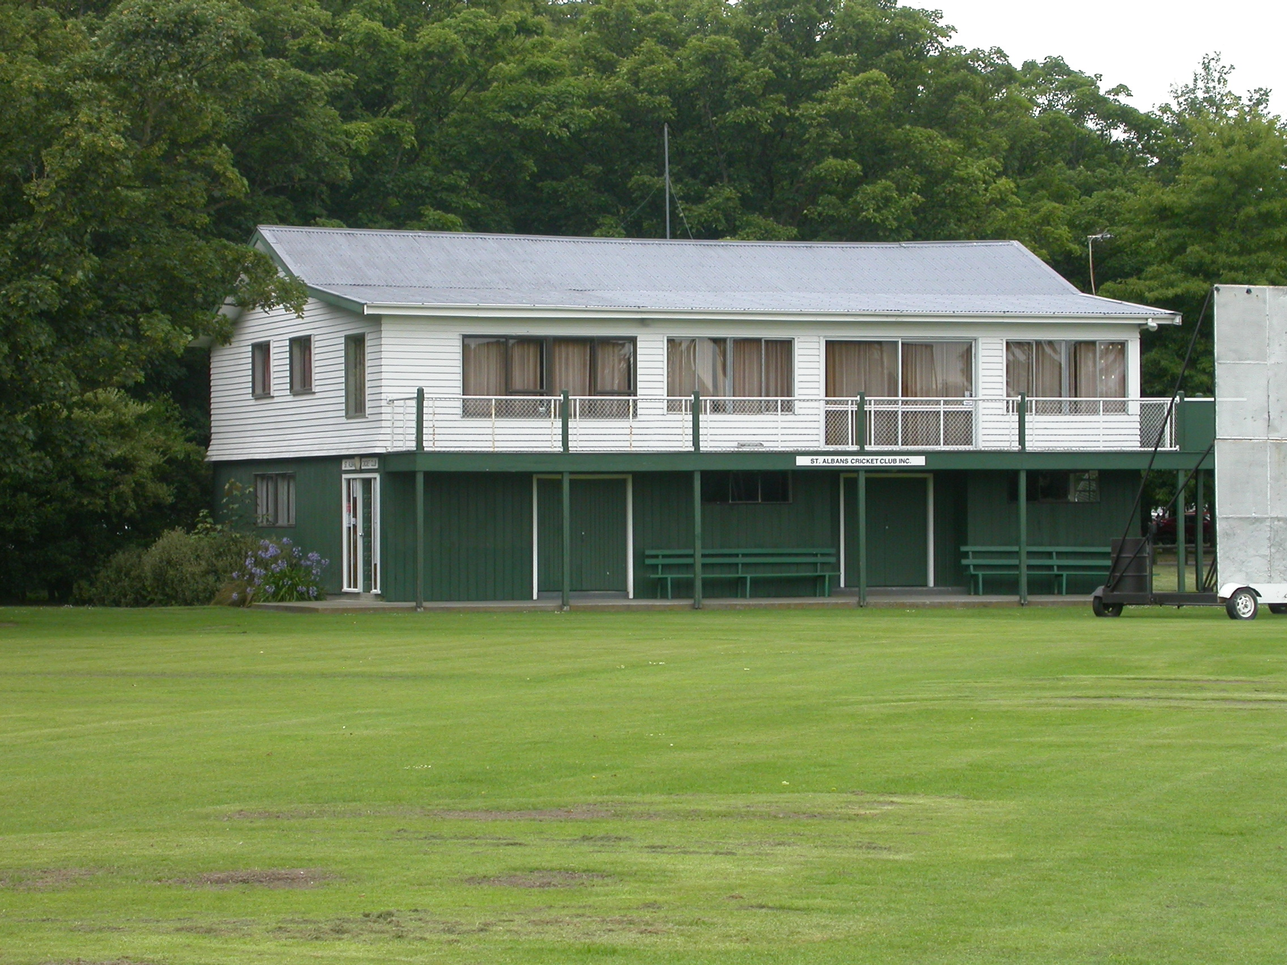

Home Ground Hagley Oval
Match pitches 2 grass match pitches
Practice pitches Grass block. artificial pitches on Polo grounds

Entries 2001-02 9 men teams 6 women teams
2002-03 9 men teams 6 women team 3 junior teams
2003-04 8 men teams 6 women teams
2004-05 8 men teams 5 women teams
2005-06 8 men teams 5 women teams 1 junior team

Grade wins last 6 years
Men 2000-01 First grade 2 day Fifth grade
2001-02 First grade 2 day Fifth grade
2002-03 First grade 1 day Fourth grade
2003-04 First grade 1 day Sixth grade
2004-05 First grade 2 day Second grade 2 day Fourth grade
2005-06 First reserve grade
Women 2000-01 First grade First reserve grade
2001-02 First grade 2 and 1 day First reserve grade Fourth grade
2002-03 Third grade
2003-04 First grade 2 and 1 day Second grade Fourth grade
2004-05 Second grade Fourth grade
2005-06 First grade

Subscriptions Adult $220
Student $165
Junior $40

Income 2004/05 Subscriptions $17,429
Gaming $30,673
Total $61,585
Expenditure Grounds $5,526
Gear $6,638
Total $71,533
Deficit $9,948
Accumulated Funds $88,304

